

Oracle BPM

USER GUIDE

**Version: 1.0  
Document Revision: 1.0**



Contents

1. Introduction 1

2. Solution Overview 1

3. Pre-Requisites and Environment Configuration 1

3.1. Oracle BPM Access 1

3.2. Blue Prism Configuration 1

4. Using the Skill 1

4.1. Retrieve a Task List 1

4.2. Add a Task Comment 1

4.3. Add a Case Comment 1

4.4. Create a Process Instance 1

4.5. Perform an Action on Tasks 1

4.6. Retrieve a Task 1

5. Support 1

# Introduction

Oracle Business Process Management, a member of the Oracle Business Process Management Suite, is a complete set of tools for creating, executing, and optimizing business processes. The suite enables unparalleled collaboration between business and IT to automate and optimize business processes.

This skill exposes certain REST endpoints for Oracle BPM.

The actions which are wrapped by this skill include:

* Retrieve a Task List
* Add a Task Comment
* Add a Case Comment
* Create a Process Instance
* Perform an Action on Tasks
* Retrieve a Task

This document describes how to make use of these actions.

# Solution Overview

This skill wraps a subset of the REST endpoints available on the Oracle BPM REST interface. Additional endpoints are available on the service and may be added to this skill in the future.

# Pre-Requisites and Environment Configuration

## Oracle BPM Access

Use of this skill requires access to an instance of Oracle BPM. Furthermore, you will require a user account with sufficient permission to execute methods against the REST interfaces.

## Blue Prism Configuration

After you have imported the skill into your Blue Prism environment, you must update the details of the Oracle BPM credential template that was created for you in Credential Manager. The credential is named ***Oracle BPM***.

To update the credential details:

1. Open Blue Prism Interactive Client
2. Go to ***System → Security → Credentials***
3. Double-click on the entry titled ***Oracle BPM***
4. Enter the username and password of the Oracle BPM user account you will use

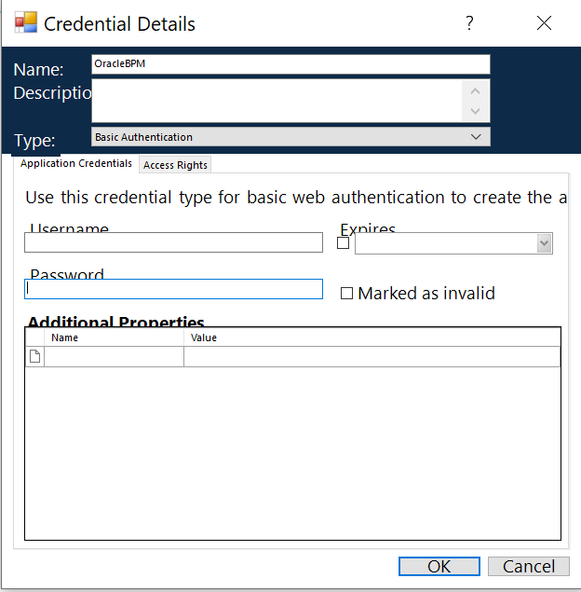

1. Next, click on the tab title ***Access Rights***.
2. Select an appropriate ***Security Role***, set the ***Processes*** that should have access to this credential, and specify which ***Resources*** can make use of the credential.

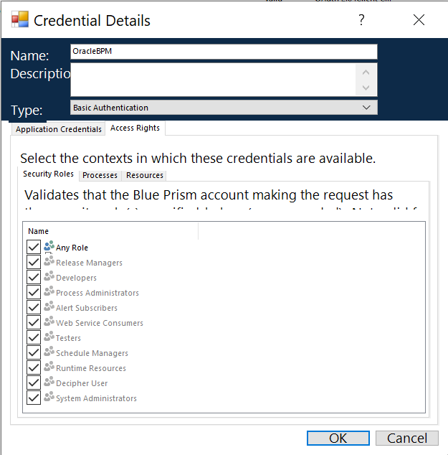

# Using the Skill

Below are the available actions in the skill and the details of the inputs/outputs that are available. For additional details, please refer <https://docs.oracle.com/middleware/1221/bpm/bpm-rest-api-ref/>.

## Retrieve a Task List

Retrieves a task list for the current user.

### Inputs

|  |  |  |
| --- | --- | --- |
| Parameter | Type | Description |
| assignment | Text | Task assignees - MY, GROUP, MY_AND_GROUP (default), MY_AND_GROUP_ALL, REPORTEES, OWNER, REVIEWER, PREVIOUS, ALL, ADMIN |
| columns | Text | Displays only the selected task attributes |
| dueDateFrom | Text | Start of due date range in the format yyyy-mm-dd hh:mm:ss |
| dueDateTo | Text | End of due date range in the format yyyy-mm-dd hh:mm:ss |
| fromuser | Text | Previous task assignee in process |
| groupBy | Text | Groups tasks by the selected task attribute |
| keyword | Text | Keyword in task title |
| limit | Number | Maximum number of items per page, between 1 and 100, default 25 |
| metadata | Text | Displays task details URL |
| offset | Number | Index for the first item on a page of list items, default 1 |
| pattern | Text | Filters tasks |
| priority | Text | Task priority from 1 (highest) to 5 (lowest) or Any (default) |
| process | Text | Includes only tasks in a given process |
| showAcion | Flag | Displays permissible task actions |
| showPermission | Flag | Displays task permissions |
| status | Text | Task status - ASSIGNED (default), SUSPENDED, WITHDRAWN, EXPIRED, ERROR, ALERTED, NEED_INFORMATION |

### Outputs

|  |  |  |
| --- | --- | --- |
| Parameter | Type | Description |
| Response_Content | Text | A JSON value containing response information related to the request. |
| HTTP Status Code | Text | HTTP Status code returned in response. |
| Response Headers | Collection | Collection of headers data returned in response. |
| totalResult | Text | Please refer <https://docs.oracle.com/middleware/1221/bpm/bpm-rest-api-ref/op-tasks-get.html> |
| user | Collection |
| count | Text |
| hasMore | Text |
| items | Collection |
| links | Collection |

## Add a Task Comment

Adds a comment to a task.

### Inputs

|  |  |  |
| --- | --- | --- |
| Parameter | Type | Description |
| commentStr | Text | Comment to be added to the task |

### Outputs

|  |  |  |
| --- | --- | --- |
| Parameter | Type | Description |
| Response_Content | Text | A JSON value containing response information related to the request. |
| HTTP Status Code | Text | HTTP Status code returned in response. |
| Response Headers | Collection | Collection of headers data returned in response. |
| levels | Text | Please refer <https://docs.oracle.com/middleware/1221/bpm/bpm-rest-api-ref/op-tasks-%7Bid%7D-comments-post.html> |
| links | Collection |
| comment | Collection |

## Add a Case Comment

Adds a comment to a case.

### Inputs

|  |  |  |
| --- | --- | --- |
| Parameter | Type | Description |
| commentStr | Text | Comment to be added to the case |

### Outputs

|  |  |  |
| --- | --- | --- |
| Parameter | Type | Description |
| Response_Content | Text | A JSON value containing response information related to the request. |
| HTTP Status Code | Text | HTTP Status code returned in response. |
| Response Headers | Collection | Collection of headers data returned in response. |
| type | Text | Please refer <https://docs.oracle.com/middleware/1221/bpm/bpm-rest-api-ref/op-cases-%7Bid%7D-comments-post.html> |
| levels | Text |
| links | Collection |
| comment | Collection |

## Create a Process Instance

Creates a process instance.

### Inputs

|  |  |  |
| --- | --- | --- |
| Parameter | Type | Description |
| processDefId | Text | Unique ID of the process |
| serviceName | Text | Name of the process service to be invoked |
| operation | Text | start |
| payload | Text | Data to be passed to the process in xml format |

### Outputs

|  |  |  |
| --- | --- | --- |
| Parameter | Type | Description |
| Response_Content | Text | A JSON value containing response information related to the request. |
| HTTP Status Code | Text | HTTP Status code returned in response. |
| Response Headers | Collection | Collection of headers data returned in response. |

## Perform an Action on Tasks

Performs an action on a set of tasks defined by their IDs.

### Inputs

|  |  |  |
| --- | --- | --- |
| Parameter | Type | Description |
| tasks | Text | IDs of the tasks. E.g. ["200041","200042"] |
| action | Text | Action to be performed on the task. E.g. ESCALATE, ACQUIRE, RELEASE, WITHDRAW, SUSPEND, RESUME, DELETE, PURGE, RENEW, or a custom action. |
| Comment | Text | Comment to be added to the task. E.g. {  "commentStr":"BulkReassign",  "commentScope":"TASK"  } |
| identities | Text | UserIDs for the task action. E.g. [{  "id":"jlondon",  "type":"user"  },  {  "id":"cdickens",  "type":"user"  }] |

### Outputs

|  |  |  |
| --- | --- | --- |
| Parameter | Type | Description |
| totalResult | Text | Please refer <https://docs.oracle.com/middleware/1221/bpm/bpm-rest-api-ref/op-tasks-put.html> |
| user | Collection |
| hasMore | Text |
| items | Collection |

## Retrieve a Task

Retrieves a task by task ID.

### Inputs

|  |  |  |
| --- | --- | --- |
| Parameter | Type | Description |
| expanded | Text | Comments, Attachments History in expanded form |
| metadata | Text | Lists task details URL |

### Outputs

|  |  |  |
| --- | --- | --- |
| Parameter | Type | Description |
| Response_Content | Text | A JSON value containing response information related to the request. |
| HTTP Status Code | Text | HTTP Status code returned in response. |
| Response Headers | Collection | Collection of headers data returned in response. |
| updatedDate | Text | Please refer <https://docs.oracle.com/middleware/1221/bpm/bpm-rest-api-ref/op-tasks-%7Bid%7D-get.html> |
| priority | Text |
| startDate | Text |
| assignedDate | Text |
| createdDate | Text |
| ownerUser | Text |
| creator | Text |
| actionList | Collection |
| number | Text |
| links | Collection |
| hasSubTasks | Text |
| title | Text |
| history | Collection |
| type | Text |
| comments | Collection |
| dueDate | Text |
| payload | Collection |
| attachments | Text |

# Support

Support for this skill is provided via the Blue Prism Digital Exchange Community Forum. Post your questions here:

[Digital Exchange Community Forum](https://community.blueprism.com/communities/community-home?communitykey=1e516cfe-4d1f-4de9-a9eb-58d15bf38c81&tab=groupdetails)